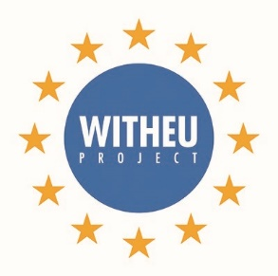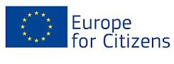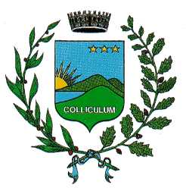
CONFERENCE
ORIGINS AND EFFECTS OF EUROSCEPTICISM ON CITIZENS’ LIFE
Saturday, 17 September 2016
Collecchio, Villa Soragna

Italian -English translation available

9.00-9.30 Registration of the participants
9.30 Welcome speech of the Mayor of Collecchio, Paolo Bianchi
9.45 Presentation of the project “WITHEU”, Laura Avanzi, project manager
10.00 Origins and reasons of today euroscepticism - Marco Baldassari, senior researcher on European integration, European College of Parma
10.30 How would be a day without Europe’s policies and rights? Overview and effects for students, young people, consumers- Andrea Poluzzi, Europe Direct Emilia
11.00 coffee break
11.20 Euroscepticism in the project partnering countries
- Dr. Norbert Kartmann, President of the Regional Assembly of Hessen – Euroscepticism and the opportunities of a European partnership among Regions and Municipalities
- Julie Bollini, Municipality of Wells – Euroscepticism and Brexit: a voice from inside
- Pascal Tshibanda, Municipality of Falkoping – Communication and Euroscepticism
12.20 Question time
Video message of MEP Cecile Kyenge as conclusion of the conference
  - Conclusion

The conference is inserted in the project “WITHEU” cofinanced by the programme Europe for Citizens of the European Union

